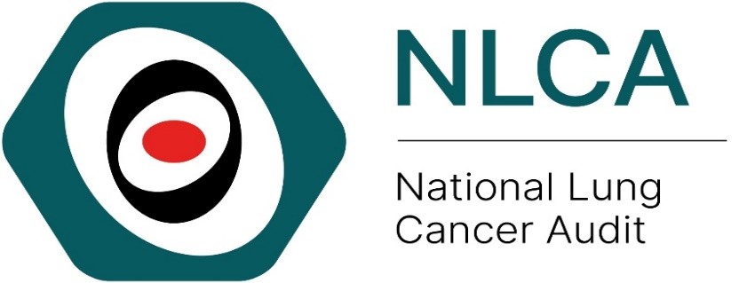
Local Action Plan for taking on Recommendations from NLCA State of the Nation Report 2025
The provider should complete the following details to allow for ease of review
Audit title & aim: | National Lung Cancer Audit (NLCA)  To assess the process of care and its outcomes in patients with lung cancer
NHS organisation:

Audit lead:

Action plan lead:

When making your action plan, make sure to keep the objectives SMART – Specific, Measurable, Assignable, Realistic, Time-related
This quality improvement template is designed to be used in conjunction with the NLCA State of the Nation Report 2025 provider level results on our interactive data dashboard and quality improvement resources presented on our website.

Key 1 (for the action status)
- Awaiting plan of action
- Action in progress
- Action fully implemented
- No plan to action recommendation (state reason)
- Other (provide information)
Key 2 (for the action priority)
High: requires urgent attention (local audit)
Medium: requires prompt action (consider local audit)
Low: requires no immediate action (or local audit)

 |  |  | Action activities
No. | Recommendation | Action required? | Responsible individual(s) | Agreed deadline | Status (Key 1) | Priority (Key 2)
1 | Ensure services maximise the uptake of lung cancer screening for people aged 55 to 74 who are at high risk of lung cancer. | Suggested actions:  - Review local screening implementation including local uptake rates and referral processes  - Identify barriers to screening implementation  - Ensure services are prepared for increased workload related to screening programme
2 | Ensure providers have sufficient thoracic surgery capacity to accommodate the larger number of people with Non-Small Cell Lung Cancer (NSCLC) who are candidates for curative surgery. | Suggested actions:  - Review local rate of NSCLC having surgery using NLCA dashboard  - Estimate increase surgical workload due to screening  - Review local waiting times from referral to surgery  - Develop local plans to increase surgical capacity including MDTs, clinics, theatre time and post-operative hospital stays
3 | Identify opportunities for increasing the proportion of people with NSCLC stage 3B-4 (PS 0-1) to have Systemic Anti-Cancer Therapy (SACT) as per NICE guidance, such as help people maintain their fitness for SACT throughout the care pathway. | Suggested actions:  - Review local rate of NSCLC stage 3B-4, PS 0-1 receiving SACT using NLCA dashboard  - Feedback quarterly data reports to the wider MDT  - Identify and address barriers to SACT
4 | Ensure NHS hospitals have the necessary resources and capacity to meet the timelines for patients to start primary treatment. | Suggested actions:  - Review National Optimal Lung Cancer Pathway (NOLCP)  - Review own MDT wait times  - Identify and address any local delays in NOLCP pathway
5 | Ensure NHS hospitals have the necessary resources and capacity so that biomarker test results are delivered within 14 calendar days of the test being performed, as defined in the National Optimal Lung Cancer Pathway | Suggested actions:  - Review National Optimal Lung Cancer Pathway (NOLCP) regarding biomarker testing turnover times  - Monitor turn-around time for biomarker testing  - Process map pathways to improve turn-around time of biomarker testing and delivery of SACT

Please contact the NLCA team nlca@rcseng.ac.uk if you have any questions related to your results, data collection or service improvement. We also welcome on feedback on the audit, report or quality improvement resources.

References
- NLCA State of the Nation Report 2025 www.lungcanceraudit.org.uk
- NICE Guidelines Lung Cancer - Lung cancer: diagnosis and management (2019) NICE guideline [NG122] Treatment | Lung cancer: diagnosis and management | Guidance | NICE
- NHS England. National Optimal Lung Cancer Pathway (NOLCP) https://rmpartners.nhs.uk/wp-content/uploads/2024/09/national-optimal-lung-cancer-pathway_v4_01jan2024.pdf
- NHS Wales. National Optimal Lung Cancer Pathway (NOLCP) NHS Wales. National optimal pathway for lung cancer: 2nd Edition (2022)

