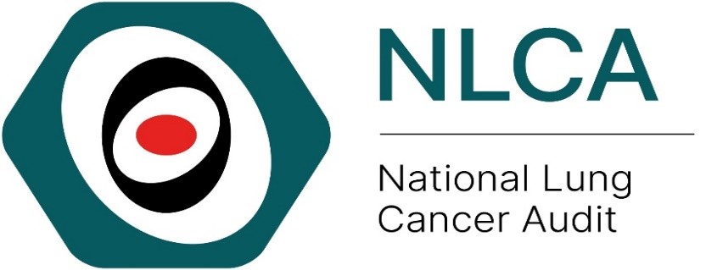
Local Action Plan for taking on NLCA State of the Nation Report 2024
The provider should complete the following details to allow for ease of review
Audit title & aim: | National Lung Cancer Audit (NLCA)  To assess the process of care and its outcomes in patients with lung cancer
NHS organisation:

Audit lead:

Action plan lead:

When making your action plan, make sure to keep the objectives SMART – Specific, Measurable, Assignable, Realistic, Time-related

Key 1 (for the action status)
- Awaiting plan of action
- Action in progress
- Action fully implemented
- No plan to action recommendation (state reason)
- Other (provide information)
Key 2 (for the action priority)
High: requires urgent attention (local audit)
Medium: requires prompt action (consider local audit)
Low: requires no immediate action (or local audit)

 |  |  | Action activities
No. | Recommendation | Action required? | Responsible individual(s) | Agreed deadline | Status (Key 1) | Priority (Key 2)
1 | Ensure services are implementing targeted lung cancer screening for people aged 55 to 74 who are at high risk of lung cancer. | Suggested actions:  - Review local screening implementation including local uptake rates and referral processes  - Identify barriers to screening implementation  - Ensure services are prepared for increased workload related to screening programme
2 | Ensure providers have capacity to meet both current demand for curative surgery and to accommodate the increase in activity caused by the national rollout of the Targeted Lung Health Check programme. | Suggested actions:  - Estimate increase surgical workload due to screening  - Develop local plans to increase surgical capacity including MDTs, clinics, theatre time and post-operative hospital stays
3 | Ensure NHS hospitals have the necessary resources and capacity (1) to reduce the proportion of patients waiting more than 21 days from treatment decision to first treatment, and (2) for biomarker testing and the timely delivery of results for patients considered for systemic anti-cancer therapy (SACT). | Suggested actions:  - Review National Optimal Lung Cancer Pathway (NOLCP)  - Review own MDT wait times  - Identify own delays in NOLCP pathway  - Feedback monthly data reports to the wider MDT  - Monitor turn-around time for biomarker testing  - Develop local pathways to improve turn-around time of biomarker testing and delivery of SACT
4 | Ensure at least 70% of patients with NSCLC stage IIIB-IVB and PS 0-1 receive systemic anti-cancer therapy (SACT) in line with NICE guidance. | Suggested actions:  - Review own MDT performance of treatment of advanced NSCLC  - Feedback monthly data reports to the wider MDT  - Identify barriers to SACT
5 | Aim to achieve high levels of data completeness in the cancer registration datasets, particularly the Rapid Cancer Registration Dataset and Cancer Outcome and Services Dataset (COSD) in England. | Suggested actions:  - Appoint a clinical data lead with protected time for reviewing and checking the team’s data returns and for championing improvements in the completeness of key data items.  - Review the completeness of key data items including TNM staging information, lung cancer nurse specialist, smoking status and Performance status submitted to the National Cancer Registration and Analysis Service  - Raise the profile of data completeness across the wider multidisciplinary team (MDT) at governance meetings or by sharing data.  - Feedback quarterly data quality reports to the wider MDT.  Integrate data collection into MDT meetings with the aim of achieving 90% completeness of key data items

The NLCA welcome your feedback on this quality improvement template to be used in conjunction with the NLCA State of the Nation Report 2024 provider level results and quality improvement resources presented on our website.

Please contact the NLCA team nlca@rcseng.ac.uk if you have any questions related to your results, data collection or service improvement.

References
- NLCA State of the Nation Report 2024 www.lungcanceraudit.org.uk
- NICE Guidelines Lung Cancer - Lung cancer: diagnosis and management (2019) NICE guideline [NG122] Treatment | Lung cancer: diagnosis and management | Guidance | NICE
- National Optimal Lung Cancer Pathway (NOLCP) https://rmpartners.nhs.uk/wp-content/uploads/2023/07/National-Optimal-Lung-Cancer-Pathway-3.0-1.pdf

